LAB 3
MUHAMMAD UMAIS FAROOQ 04072313025
Setup:
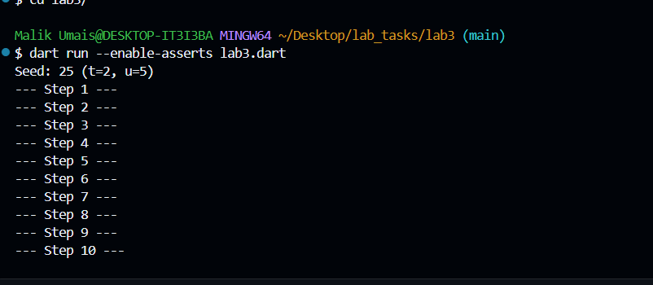
Step 1
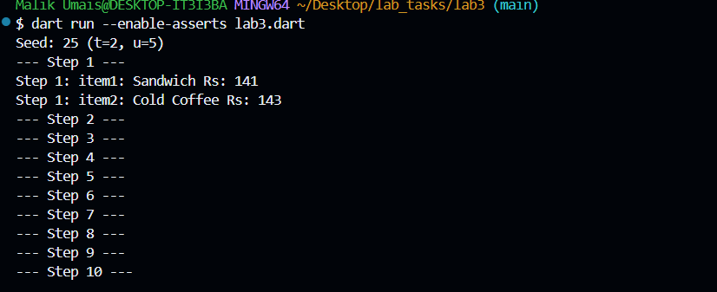

Step 2
2.1 Error for this
MenuItem(String name, int price) { this.name = name; this.price =
price; }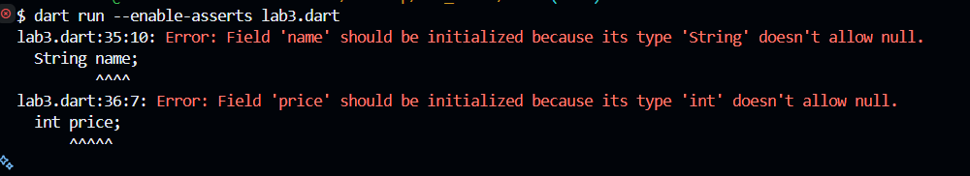
Step 2 final output
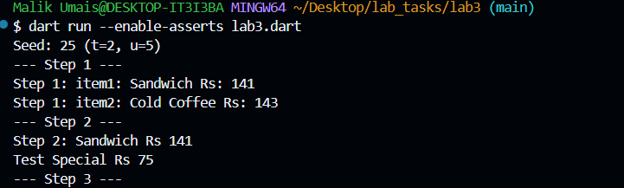
Step 3
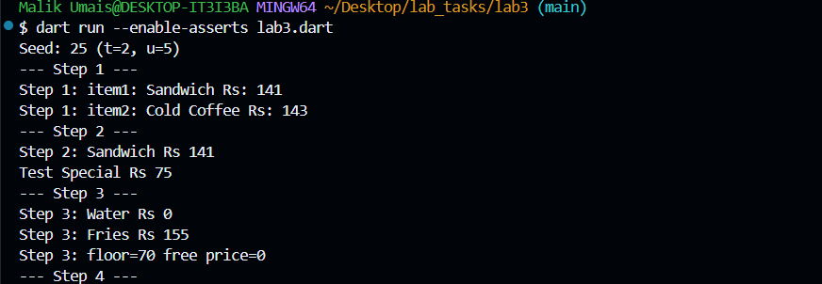

Step 4
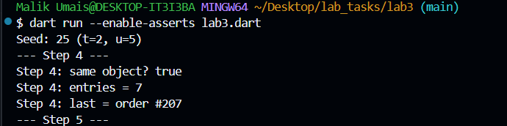
Step 5
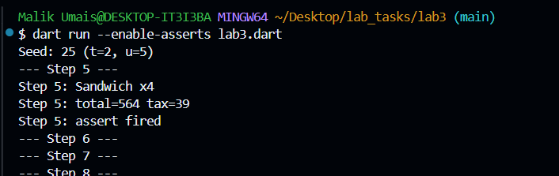
Step 6

